|  |  |
| --- | --- |
| UoR Shield | The University of Reading  Faculty of Science  School of Systems Engineering |

**SE3VR11**

**Students: Andrew Tate,**

**Casey Singlehurst,**

**Tommy Bedford,**

**Zenon Buratta**

**Degree: BSc Applied Computer Science**

**Email: A.Tate@student.reading.ac.uk**

**Assignment Title: Immersive Virtual Environment**

# Overview

# This manuscript accompanies the virtual world Claustrophobia simulator submitted by Group 4 to support the materials and concepts delivered in the SE3VR11 module. The idea of this world is based on replicating real world features that trigger symptoms of claustrophobia. Its purpose is to provide an environment where by the user can experience, control and manage claustrophobia. The virtual scene hosts five areas which each house features and challenges targeting the phobias symptoms such as revolving doors and elevators. The goal for the user is to venture through each area and interact with the features within the environment. Each area will present more challenging features as the user progresses through the scene.

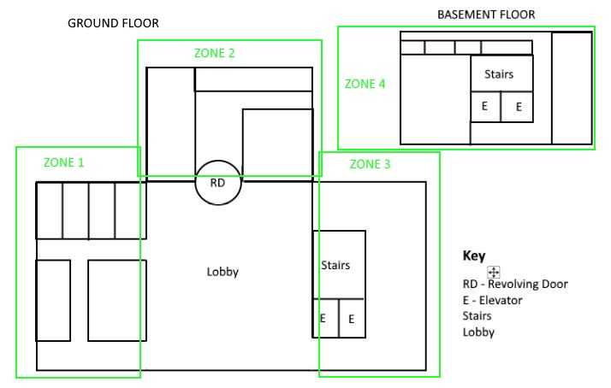

# Character Controls

↑ = forwards = jump = action

Space

↓ = backwards

← = side step left = run

Shift

→ = side step right = mouse movement to look

# Interactive features

The virtual world host some interactive doors that can be triggered by the user by pointing and clicking on the door handles. There is a revolving door that is in continuous motion where by the user can walk into one of the vacant partitions and then pass through to the next area. Another area presents an elevator that can be ridden down to the basement area of the simulator by clicking the elevator button on the wall, entering the lift and clicking the button panel inside the elevator. Some objects in the world have physics based attributes such as office chairs found in some areas.